

**UNITEDWORLD SCHOOL OF COMPUTATIONAL INTELLIGENCE (USCI)**

Summative Assessment (SA)

**Online Voting System**

Submitted BY

Viken Patel

(Enrl. No.: 20220701033)

**Course Code and Title: 21BSCS24C05-Professional Training**

B.Sc. (Hons.) Computer Science / Data Science / AIML

IV Semester – Dec 2023 – April 2024

Dec/Apr 2024

**Index**

1. **Introduction 3**
2. **Explanation 4**
3. **Project Code 6**
4. **Output 9**
5. **Conclusion 11**
6. **Bibliography 13**

**Introduction**

Ghost voters are people who do not really exist but whose votes are influenced by powerful parties in an attempt to influence election outcomes in their favor. This is a problem that is often observed in India. By offering a personalized and safe voting experience, the suggested software solution seeks to preserve the election process's integrity. Every qualified voter will be given the chance to cast their ballots within this project during a predetermined window of time, free from outside interference. The poll will only be open to Indian nationals who are at least eighteen years old, and each voter will need to authenticate themselves with a unique user ID and password. The capacity for voters to choose their particular assembly districts and voting locations, guaranteeing a legal and private casting of their ballots in favor of their preferred leaders.

The project discusses India's requirement to switch from a manual to an online voting system, utilizing cutting-edge technology to increase efficiency, speed, and accuracy. This thesis proposes an online approach in response to issues that the manual system has caused for voters and the government. Voters would have the option to use government-provided resources or their own devices for voter registration, voting, result computation, and result declaration under this proposed system. The study also highlights how such a change might help the democratic process in the long run by lowering the possibility of corruption connected to the existing manual procedure.

In order to emphasize a fundamental need of an online voting system or tech-based system that would allow transparency and security, a Java-based script has been built. However, my proposal is a learning model (beginning) that will take a lot of effort to put into practice. It is limited to Java, but there are other systems that are fast, secure, and have high-end interfaces that make it possible to utilize programming languages and create apps.

**Explanation**

"Vote" refers to the process of choosing, choosing representatives, and choosing results. Like in many other countries, the main goal of voting in India is to democratically choose leaders who represent the people's desire. However, much as in other nations, voting in India is fraught with difficulties, such as election fraud, problems with polling place accessibility and security, a lack of necessary voting supplies, and a staffing shortfall. The Smart Voting System is made to successfully address these issues. This novel voting mechanism is designed to provide Indian voters enough time to cast their ballots. In order to guarantee that voters are ready for online voting prior to the election, the system also provides user training.

A simple Java programming system for online voting is implemented in the code below. The code consists of a single function named "main," which serves as the program's entry point, and a single class named "OnlineVotingSystem."  
  
The code generates three integer variables, "Name, Phone, and Party or team" and "SubmitYourVote and CheckResult," and initializes them to see the sesult at the end of the main procedure. The total number of votes cast for each contender will be stored in these variables.

The user is then prompted to enter their name and age by the code using a Scanner object to read input from them. The user's age is then verified to see if they are older than eighteen (18) and so entitled to vote. The code asks the user to choose a candidate to vote for after displaying a list of candidates if they are qualified to vote. The variable "userSelection" contains the selection made by the user.

The code then checks the value of "userSelection" and increases the vote total for the associated candidate using an if-else expression. After then, the user receives a thank-you message from the computer along with the total number of votes cast for each contender. When a user is not qualified to vote, the application notifies them of this by displaying a message. In order to free up system resources, the code finally terminates the Scanner object.

Remember that this code is only an illustration of a simple online voting system; in actuality, scalability and security are significant considerations that must be considered when putting an online voting system into place. Furthermore, this code uses the console to receive inputs. In a real-world setting, the system ought to have an easy-to-use interface, store voter data in a database, encrypt sensitive data, employ secure protocols, and have adequate session management.

**Code**

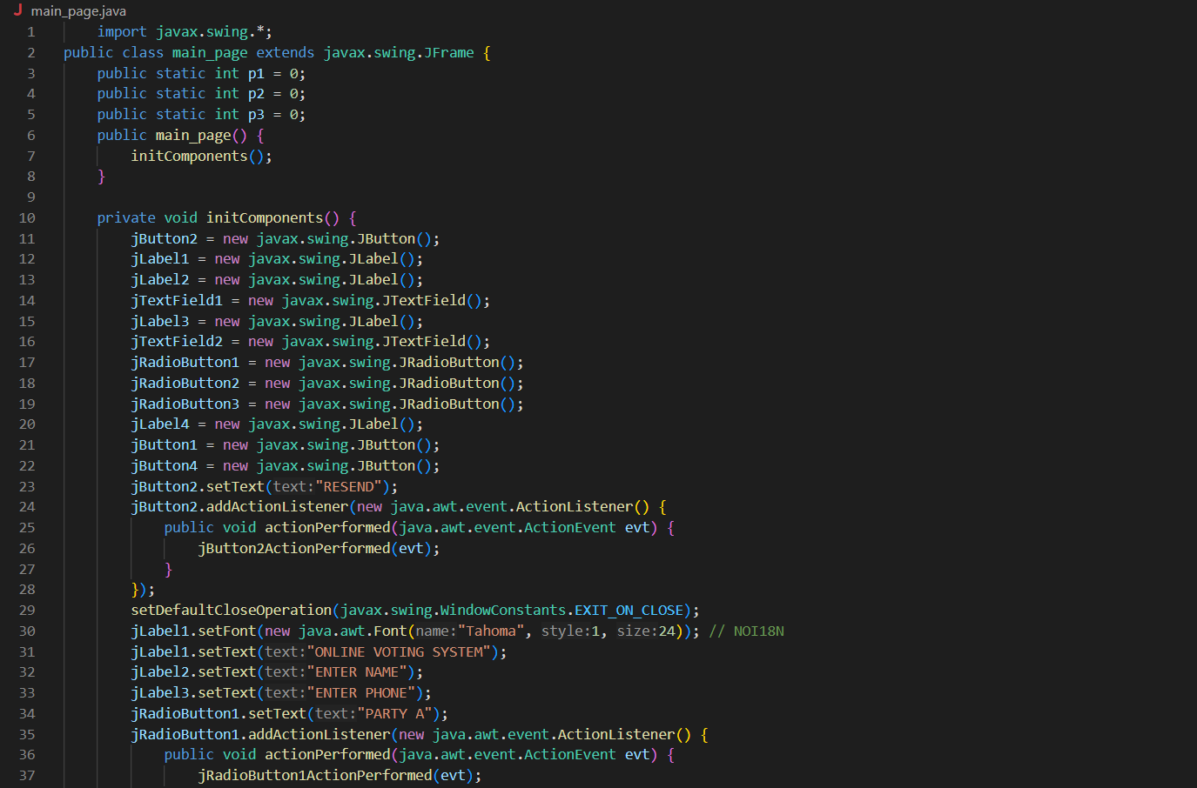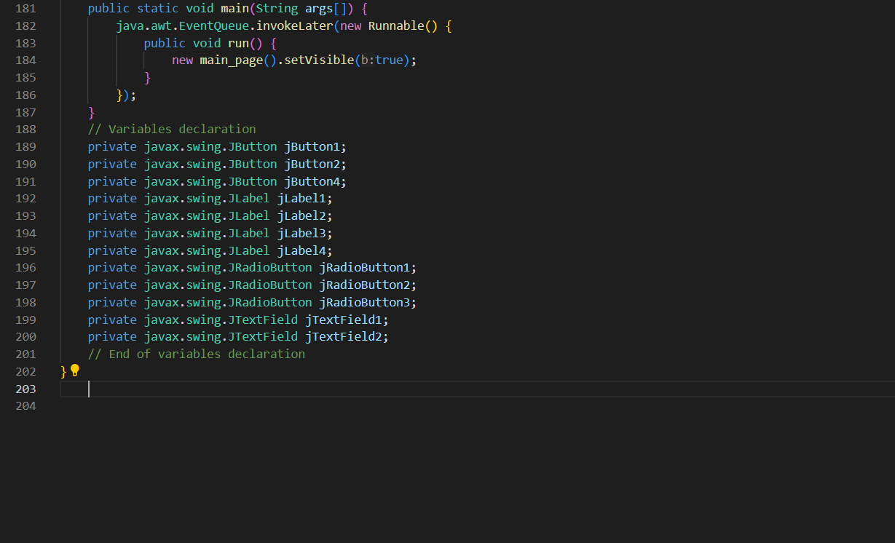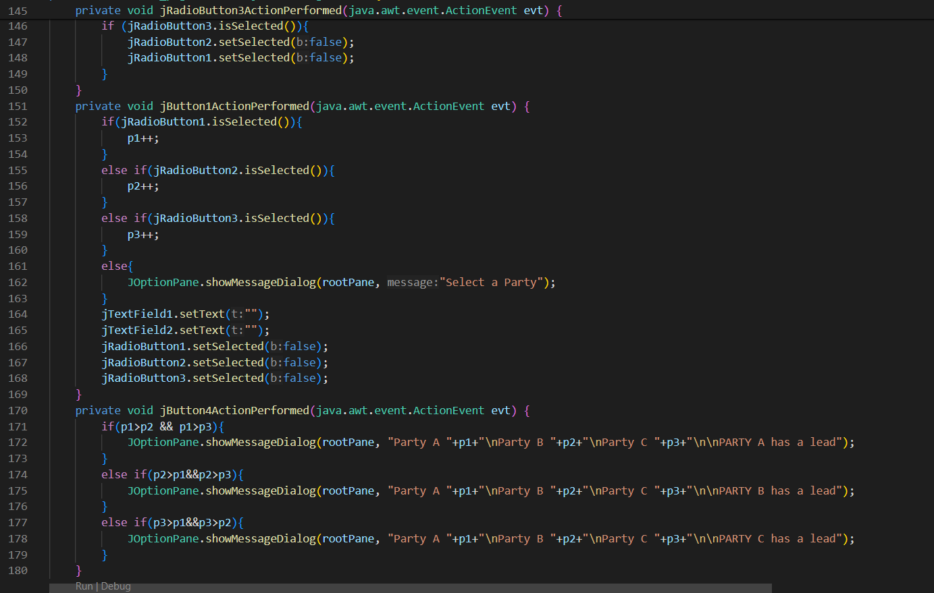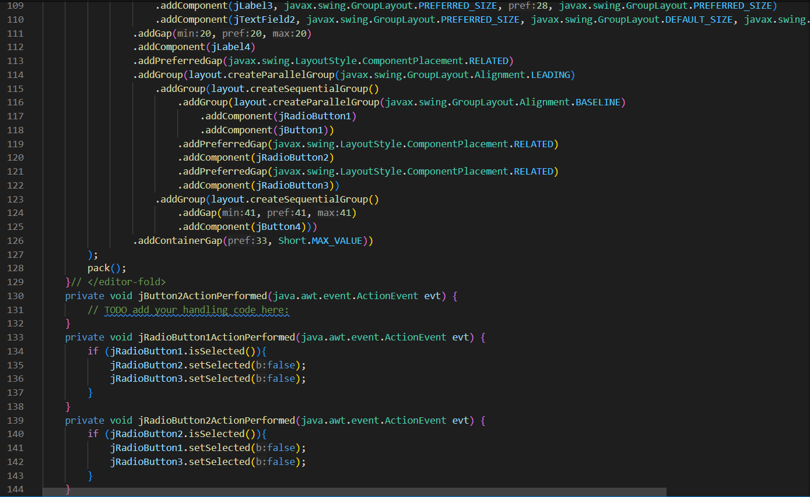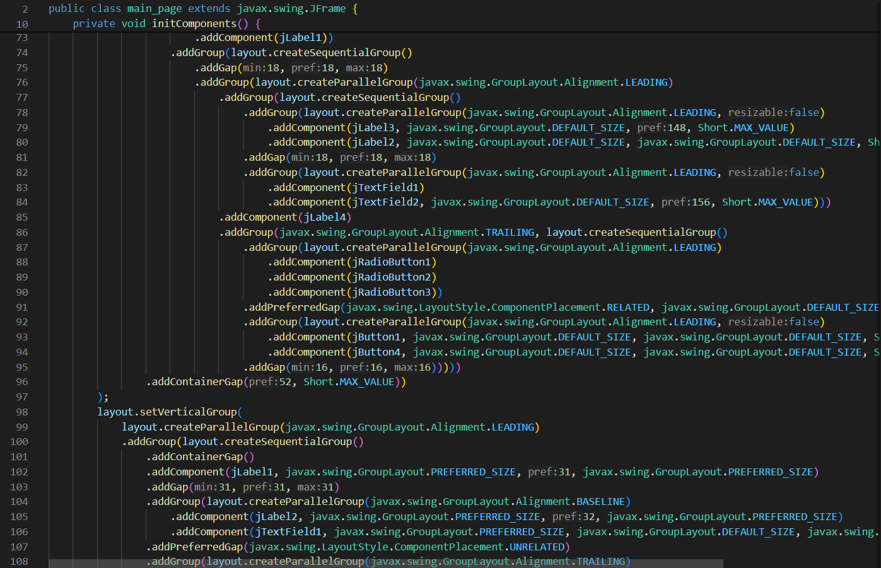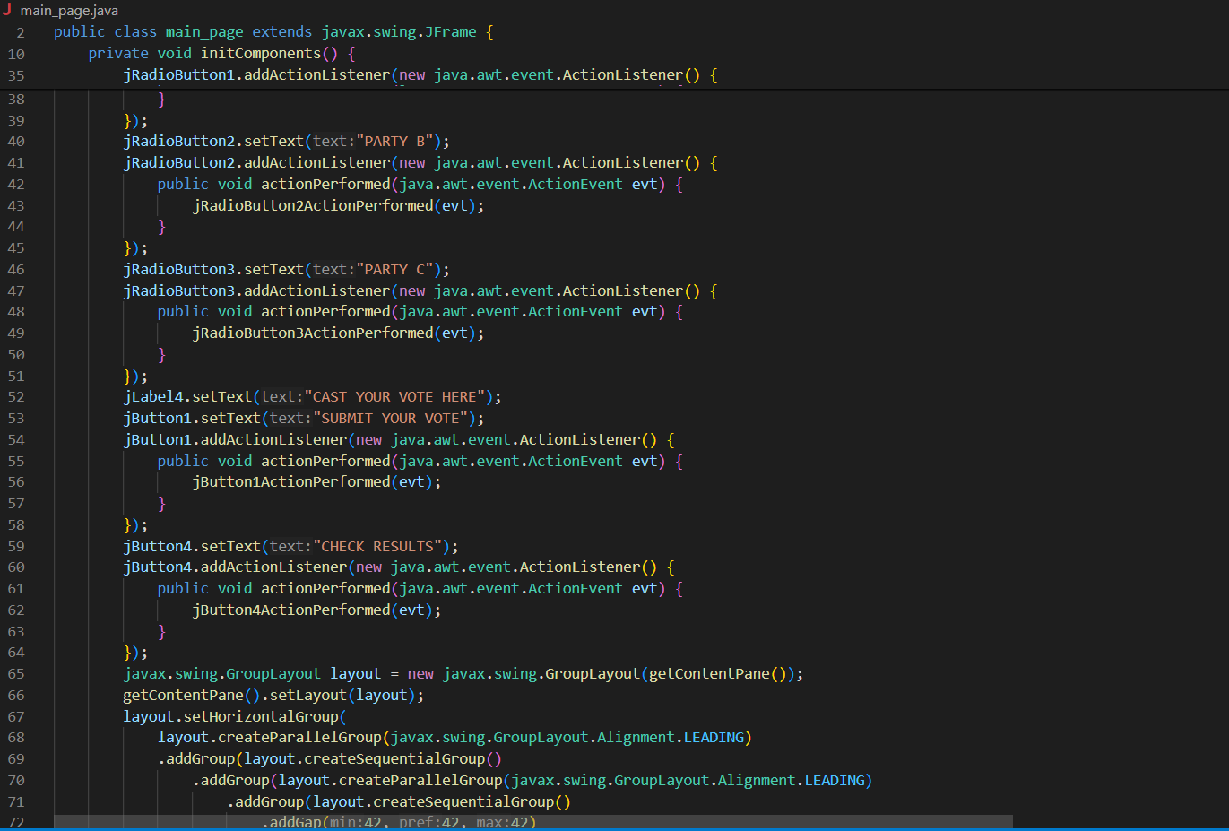

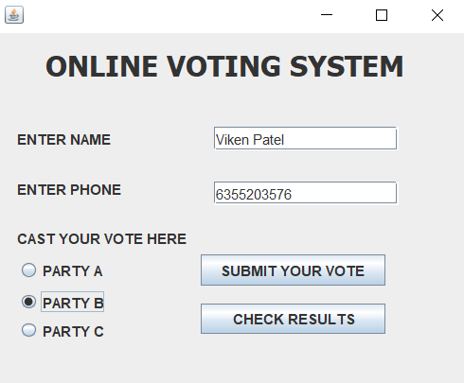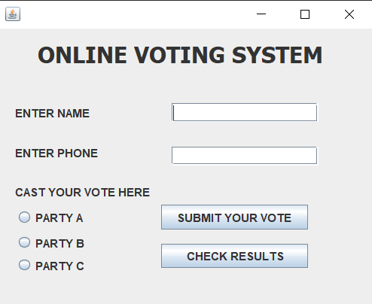**Output**

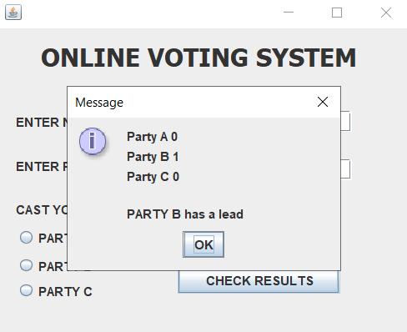

The system is composed of three parties: Party A, Party B, and Party C. All three of the parties are against some jRadioButtons. The party vote totals are contained in variables p1, p1, and p3. The user has to provide their name and phone number, select their preferred party by clicking the jRadioButton, and then click the jButton labelled "Submit Your Vote." Users have to select one party each time they cast a vote. If no party is selected, a dialog pop-up box with the title "Select a Party" appears. The dialog windows are constructed using the JOptionPane. We have to make sure that a voter cannot use their vote to support more than one party. This is made feasible by the subsequent tactic:

**Conclusion**

This online voting system will handle the voter's information, and they may utilize it to log in and use their right to vote. The voting system will have all of its components integrated within it. It calculates the total number of votes cast for each party and provides people with the option to continue voting for each one. Every voter's name and all of their personal details are kept up to date in a database maintained by the Indian Election Commission.

A voter who is at least eighteen years old must first use their ID and password to register their information in the database before they may cast a ballot. After that, they may vote once for any party. A database holds the voting information, and a computation shows the result. The online voting process raises the percentage of votes cast. It reduces the cost and duration of the voting procedure. It's really easy to use and takes very little work. Debugging is really easy.

**References**

Patidar, Bhupendra. 2022. “Online Voting System Project in Java with Source Code and Project Report.” *Codebun*. March 26.

<https://codebun.com/online-voting-system-project-in-java-with-source-code-and-project-report/>.

#### “PROJECT REPORT_ONLINE VOTING SYSTEM.” 2012. *SlideShare*. Slideshare. July 28.

#### <https://www.slideshare.net/wilsonnandasaba/project-reportonline-voting-system>.

#### “Online Voting System Report - [DOCX Document].” 2024. *Vdocument.In*. Accessed April 1. <https://vdocument.in/online-voting-system-report.html>.

#### “Build Software Better, Together.” 2024. *GitHub*. Accessed April 1. <https://github.com/topics/voting-system?l=java>.

#### “Project Report of Online Voting System.” 2024. *Scribd*. Scribd. Accessed April 1. <https://www.scribd.com/document/550446048/Project-Report-of-Online-Voting-System>.

**Plagiarism**

